Chapter 5

1. Write an **if**-statement that takes two integer variables and **exchanges** their values if the first one is greater than the second one.

using System;

namespace _01_greaterSwitchV

{

class Program

{

static void Main(string[] args)

{

Console.Write("Write the first number: ");

int num1 = Convert.ToInt32(Console.ReadLine());

Console.Write("Write the second number: ");

int num2 = Convert.ToInt32(Console.ReadLine());

if (num1 > num2)

{

num2 = num1;

Console.WriteLine(num2);

}

else if(num2 > num1)

{

num1 = num2;

Console.WriteLine(num1);

}else if (num1 == num2)

{

Console.WriteLine("Numbers are equal");

}

}

}

}

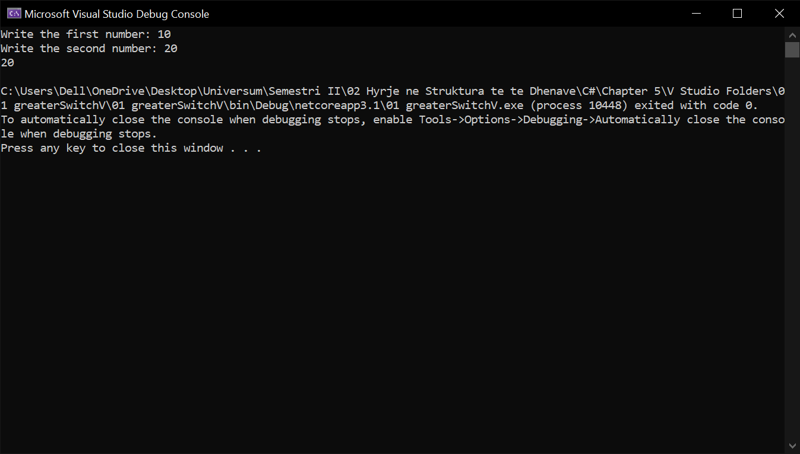

1. Write a program that shows the sign (**+** or **-**) of the product of three real numbers, without calculating it. Use a sequence of **if** operators.

using System;

namespace _02_checking9numbers

{

class Program

{

static void Main(string[] args)

{

Console.WriteLine("Write a number ");

int a = int.Parse(Console.ReadLine());

switch(a)

{

case 1:a = 1;

Console.WriteLine("ONE");

break;

case 2:

a = 2;

Console.WriteLine("Two");

break;

case 3:

a = 3;

Console.WriteLine("THREE");

break;

case 4:

a = 4;

Console.WriteLine("FOUR");

break;

case 5:

a = 5;

Console.WriteLine("FIVE");

break;

case 6:

a = 6;

Console.WriteLine("SIX");

break;

case 7:

a = 7;

Console.WriteLine("SEVEN");

break;

case 8:

a = 8;

Console.WriteLine("EIGHT");

break;

case 9:

a = 9;

Console.WriteLine("NINE");

break;

}

}

}

}

1. Write a program that finds the **biggest of three integers**, using nested **if** statements.

using System;

namespace _03_findingGreater3

{

class Program

{

static void Main(string[] args)

{

Console.WriteLine("Write 3 numbers: ");

int a = Convert.ToInt32(Console.ReadLine());

int b = Convert.ToInt32(Console.ReadLine());

int c = Convert.ToInt32(Console.ReadLine());

if (a > b)

if (a > c) Console.WriteLine("A is the biggest");

else if (a < c) Console.WriteLine("C is the biggest");

else Console.WriteLine("A and C are the biggest");

else if (a < b)

if (b > c) Console.WriteLine("B is the biggest");

else if (b < c) Console.WriteLine("C is the biggest");

else Console.WriteLine("B and C are the biggest");

else if (a == b)

if (a == c) Console.WriteLine("All are equal");

else if (a < c) Console.WriteLine("C is the biggest");

else Console.WriteLine("A and B are the biggest");

}

}

}

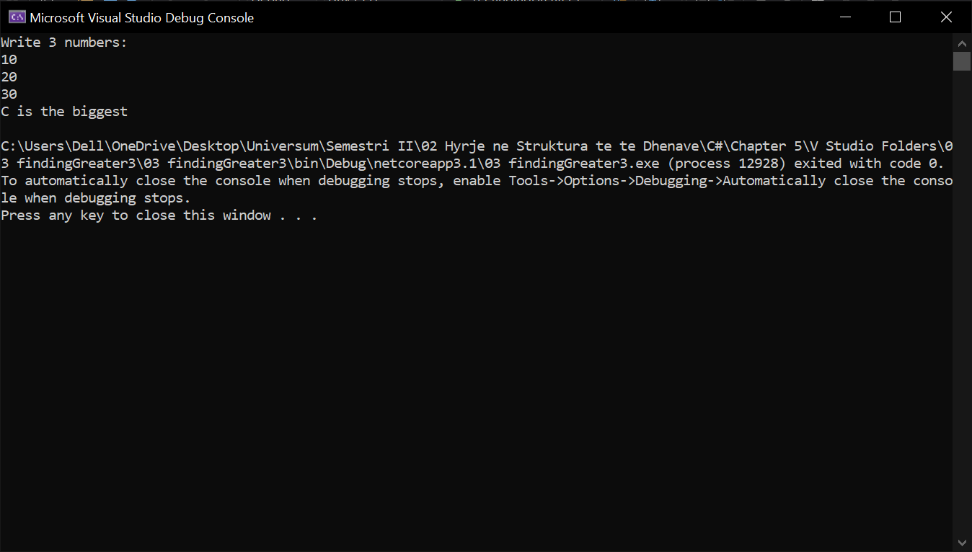

1. **Sort 3 real numbers** in descending order. Use nested **if** statements.

using System;

namespace _04_sorting3Numbers

{

class Program

{

static void Main(string[] args)

{

Console.Write("Enter first number: ");

int a = Int32.Parse(Console.ReadLine());

Console.Write("Enter second number: ");

int b = Int32.Parse(Console.ReadLine());

Console.Write("Enter third number: ");

int c = Int32.Parse(Console.ReadLine());

if (a < b)

{

if (a < c)

{

a = a + c;

c = a - c;

a = a - c;

if (b > c)

{

a = a + b;

b = a - b;

a = a - b;

}

}

else if (a >= c)

{

a = a + b;

b = a - b;

a = a - b;

}

}

else if (a == b)

{

if (a < c)

{

a = a + c;

c = a - c;

a = a - c;

}

}

else

{

if (b < c)

{

b = b + c;

c = b - c;

b = b - c;

}

if (a < b)

{

a = a + b;

b = a - b;

a = a - b;

}

}

Console.WriteLine("{0}, {1}, {2}", a, b, c);

}

}

}

1. Write a program that asks for a digit (0-9), and depending on the input, **shows the digit as a word** (in English). Use a **switch** statement.

using System;

namespace _05_showingDigitsNames

{

class Program

{

static void Main(string[] args)

{

Console.Write("Shkruaj nje numer: ");

int number = Int32.Parse(Console.ReadLine());

switch (number)

{

case 0: Console.WriteLine("zero"); break;

case 1: Console.WriteLine("nje"); break;

case 2: Console.WriteLine("dy"); break;

case 3: Console.WriteLine("tre"); break;

case 4: Console.WriteLine("kater"); break;

case 5: Console.WriteLine("Pes"); break;

case 6: Console.WriteLine("gjashte"); break;

case 7: Console.WriteLine("shtate"); break;

case 8: Console.WriteLine("tet"); break;

case 9: Console.WriteLine("nente"); break;

default: Console.WriteLine("gabim ne input"); break;

}

}

}

}

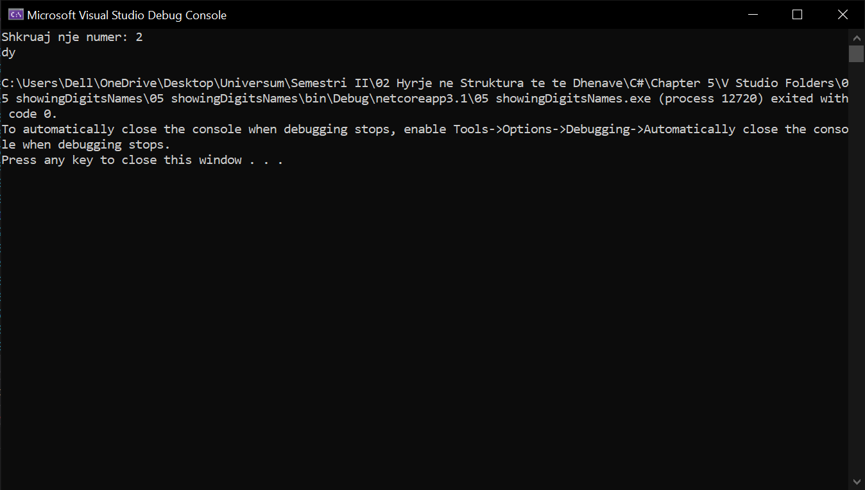

1. Write a program that gets the coefficients ***a***, ***b*** and ***c*** of a quadratic equation: ***a*x2** **+** ***b*x** **+** ***c***, calculates and prints its real roots (if they exist). Quadratic equations may have 0, 1 or 2 real roots.

using System;

namespace _06_coefficientABC

{

class Program

{

static void Main(string[] args)

{

Console.Write("Input A (not 0): ");

sbyte a = Convert.ToSByte(Console.ReadLine());

Console.Write("Input B: ");

sbyte b = Convert.ToSByte(Console.ReadLine());

Console.Write("Input C: ");

sbyte c = Convert.ToSByte(Console.ReadLine());

sbyte d = (sbyte)(b * b - 4 * a * c);

if (d < 0)

Console.WriteLine("\nD={0}\nThere are no real roots.", d);

else if (d == 0)

{

sbyte x1 = (sbyte)(-b / 2 * a);

Console.WriteLine("\nX={0}", x1);

}

else

{

sbyte x1 = (sbyte)((-b + Math.Sqrt(d)) / (2 * a));

sbyte x2 = (sbyte)((-b - Math.Sqrt(d)) / (2 * a));

Console.WriteLine("\nX1={0}\nX2={1}", x1, x2);

}

}

}

}

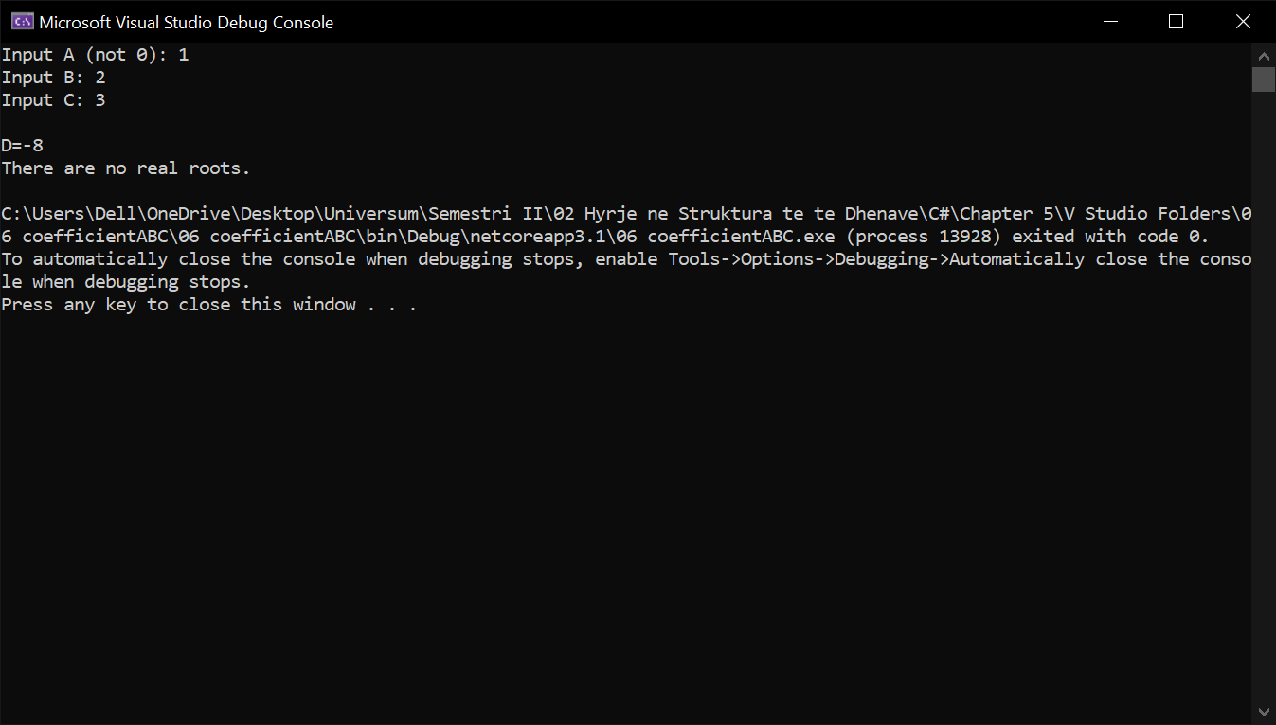

1. Write a program that finds the **greatest of given 5 numbers**.

using System;

namespace _07_greatesOf5

{

class Program

{

static void Main(string[] args)

{

Console.Write("Enter first number: ");

int a = Int32.Parse(Console.ReadLine());

Console.Write("Enter second number: ");

int b = Int32.Parse(Console.ReadLine());

Console.Write("Enter third number: ");

int c = Int32.Parse(Console.ReadLine());

Console.Write("Enter fourth number: ");

int d = Int32.Parse(Console.ReadLine());

Console.Write("Enter fifth number: ");

int e = Int32.Parse(Console.ReadLine());

if (a < b) a = b;

if (a < c) a = c;

if (a < d) a = d;

if (a < e) a = e;

Console.WriteLine("{0} is the biggest number.", a);

}

}

}

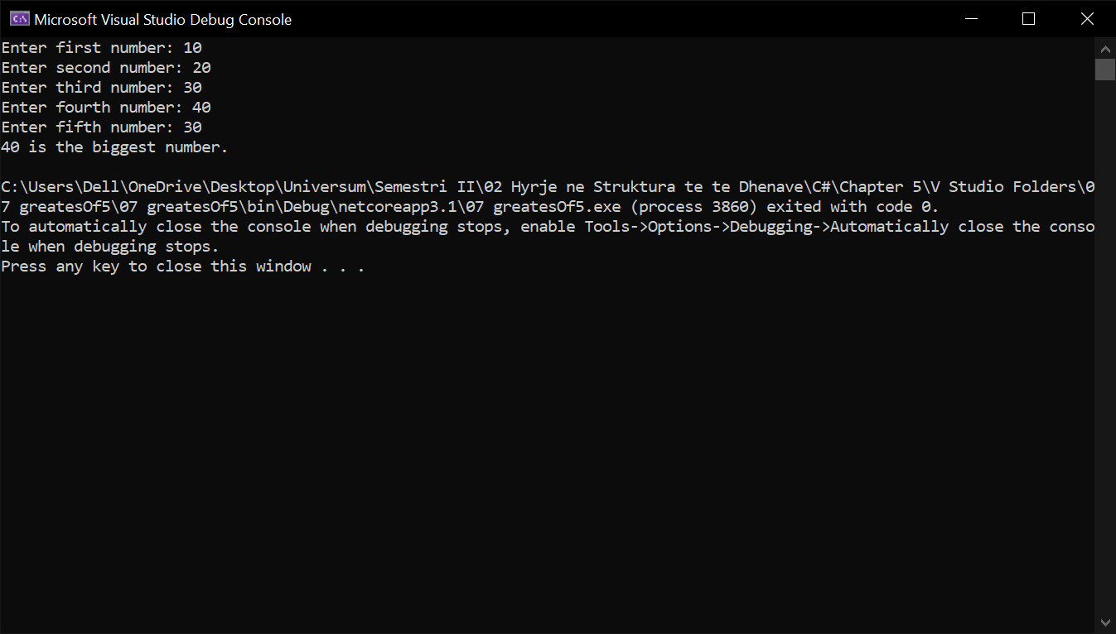

1. Write a program that, depending on the user’s choice, inputs **int**, **double** or **string** variable. If the variable is **int** or **double**, the program increases it by 1. If the variable is a **string**, the program appends "**\***" at the end. Print the result at the console. Use **switch** statement.

using System;

namespace _08_askingfor_somthing

{

class Program

{

static void Main(string[] args)

{

Console.WriteLine("Shtyp 1 per integer, 2 per double dhe 3 per string ");

int intVar = int.Parse(Console.ReadLine());

switch(intVar){

case 1:

{

Console.Write("Enter int variable: ");

intVar = Int32.Parse(Console.ReadLine());

intVar++;

Console.WriteLine("Int variable +1 = {0}", intVar);

break;

}

case 2:

{

Console.Write("Enter double variable: ");

double doubleVar = double.Parse(Console.ReadLine());

doubleVar++;

Console.WriteLine("Double variable +1 = {0}", doubleVar);

break;

}

case 3:

{

Console.Write("Enter string variable: ");

string stringVar = Console.ReadLine();

stringVar = stringVar + '*';

Console.WriteLine("String variable +* = {0}", stringVar);

break;

}

default: Console.WriteLine("Wrong input"); break;

}

}

}

}

1. We are given 5 integer numbers. Write a program that finds those **subsets whose sum is 0**. Examples:

-     If we are given the numbers {3, -2, 1, 1, 8}, the sum of -2, 1 and 1 is 0.

-     If we are given the numbers {3, 1, -7, 35, 22}, there are no subsets with sum 0.

using System;

namespace _09_fiveIneger

{

class Program

{

static void Main(string[] args)

{

Console.Write("Enter first number: ");

sbyte first = Convert.ToSByte(Console.ReadLine());

Console.Write("Enter second number: ");

sbyte second = Convert.ToSByte(Console.ReadLine());

Console.Write("Enter third number: ");

sbyte third = Convert.ToSByte(Console.ReadLine());

Console.Write("Enter fourth number: ");

sbyte fourth = Convert.ToSByte(Console.ReadLine());

Console.Write("Enter fifth number: ");

sbyte fifth = Convert.ToSByte(Console.ReadLine());

if (first + second == 0)

Console.WriteLine("{0}+ {1} = 0", first, second);

if (first + third == 0)

Console.WriteLine("{0}+ {1} = 0", first, third);

if (first + fourth == 0)

Console.WriteLine("{0}+ {1} = 0", first, fourth);

if (first + fifth == 0)

Console.WriteLine("{0}+ {1} = 0", first, fifth);

if (second + third == 0)

Console.WriteLine("{0}+ {1} = 0", second, third);

if (second + fourth == 0)

Console.WriteLine("{0}+ {1} = 0", second, fourth);

if (second + fifth == 0)

Console.WriteLine("{0}+ {1} = 0", second, fifth);

if (third + fourth == 0)

Console.WriteLine("{0}+ {1} = 0", third, fourth);

if (third + fifth == 0)

Console.WriteLine("{0}+ {1} = 0", third, fifth);

if (fourth + fifth == 0)

Console.WriteLine("{0}+ {1} = 0", fourth, fifth);

if (first + second + third == 0)

Console.WriteLine("{0}+ {1}+ {2} = 0", first, second, third);

if (first + second + fourth == 0)

Console.WriteLine("{0}+ {1}+ {2} = 0", first, second, fourth);

if (first + second + fifth == 0)

Console.WriteLine("{0}+ {1}+ {2} = 0", first, second, fifth);

if (first + third + fourth == 0)

Console.WriteLine("{0}+ {1}+ {2} = 0", first, third, fourth);

if (first + third + fifth == 0)

Console.WriteLine("{0}+ {1}+ {2} = 0", first, third, fifth);

if (second + third + fourth == 0)

Console.WriteLine("{0}+ {1}+ {2} = 0", second, third, fourth);

if (second + third + fifth == 0)

Console.WriteLine("{0}+ {1}+ {2} = 0", second, third, fifth);

if (third + fourth + fifth == 0)

Console.WriteLine("{0}+ {1}+ {2} = 0", third, fourth, fifth);

}

}

}

1. Write a program that applies **bonus points** to given scores in the range [1…9] by the following rules:

-     If the score is between 1 and 3, the program multiplies it by 10.

-     If the score is between 4 and 6, the program multiplies it by 100.

-     If the score is between 7 and 9, the program multiplies it by 1000.

-     If the score is 0 or more than 9, the program prints an error message.

using System;

namespace _10_bonusPoints

{

class Program

{

static void Main(string[] args)

{

byte points;

Console.Write("Enter points between 1 and 9: ");

points = Convert.ToByte(Console.ReadLine());

if (points >= 1 && points <= 3)

Console.WriteLine("Points multiplied by 10: {0}", points * 10);

else if (points >= 4 && points <= 6)

Console.WriteLine("Points multiplied by 100: {0}", points * 100);

else if (points >= 7 && points <= 9)

Console.WriteLine("Points multiplied by 1000: {0}", points * 1000);

else

Console.WriteLine("Wrong Input!");

}

}

}

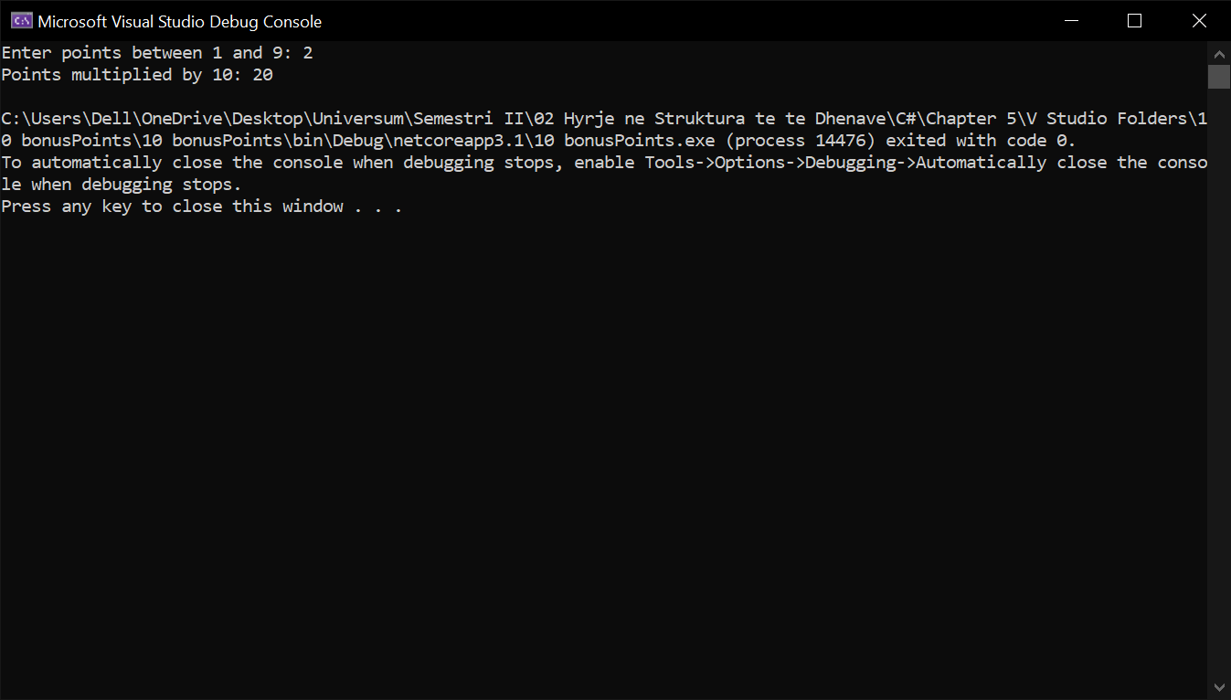

1. Write a program that **converts a number in the range [0…999] to words**, corresponding to the English pronunciation.
2. using System;
3. namespace _11_converting999
4. {
5. class Program
6. {
7. static void Main(string[] args)
8. {
9. Console.Write("Enter a number between 0 and 999: ");
10. short number = Convert.ToInt16(Console.ReadLine());
11. byte hundreds = (byte)(number / 100 | 0);
12. byte tensAndOnes;
13. if (number > 99) tensAndOnes = (byte)(number % 100);
14. else tensAndOnes = (byte)(number * 1);
15. byte ones = (byte)(number % 10);
16. switch (hundreds)
17. {
18. case 1: Console.Write("One hundred "); break;
19. case 2: Console.Write("Two hundred "); break;
20. case 3: Console.Write("Three hundred "); break;
21. case 4: Console.Write("Four hundred "); break;
22. case 5: Console.Write("Five hundred "); break;
23. case 6: Console.Write("Six hundred "); break;
24. case 7: Console.Write("Seven hundred "); break;
25. case 8: Console.Write("Eight hundred "); break;
26. case 9: Console.Write("Nine hundred "); break;
27. }
28. if (hundreds >= 1 && tensAndOnes >= 1) Console.Write("and ");
29. if (tensAndOnes >= 20 && tensAndOnes < 30) Console.Write("Twenty");
30. else if (tensAndOnes >= 30 && tensAndOnes < 40) Console.Write("Thirty");
31. else if (tensAndOnes >= 40 && tensAndOnes < 50) Console.Write("Fourty");
32. else if (tensAndOnes >= 50 && tensAndOnes < 60) Console.Write("Fifty");
33. else if (tensAndOnes >= 60 && tensAndOnes < 70) Console.Write("Sixty");
34. else if (tensAndOnes >= 70 && tensAndOnes < 80) Console.Write("Seventy");
35. else if (tensAndOnes >= 80 && tensAndOnes < 90) Console.Write("Eighty");
36. else if (tensAndOnes >= 90 && tensAndOnes < 100) Console.Write("Ninety");
37. switch (tensAndOnes)
38. {
39. case 1: Console.Write("One"); break;
40. case 2: Console.Write("Two"); break;
41. case 3: Console.Write("Three"); break;
42. case 4: Console.Write("Four"); break;
43. case 5: Console.Write("Five"); break;
44. case 6: Console.Write("Six"); break;
45. case 7: Console.Write("Seven"); break;
46. case 8: Console.Write("Eight"); break;
47. case 9: Console.Write("Nine"); break;
48. case 10: Console.Write("Ten"); break;
49. case 11: Console.Write("Eleven"); break;
50. case 12: Console.Write("Twelve"); break;
51. case 13: Console.Write("Thirteen"); break;
52. case 14: Console.Write("Fourteen"); break;
53. case 15: Console.Write("Fifteen"); break;
54. case 16: Console.Write("Sixteen"); break;
55. case 17: Console.Write("Seventeen"); break;
56. case 18: Console.Write("Eighteen"); break;
57. case 19: Console.Write("Nineteen"); break;
58. }
59. if (tensAndOnes > 20)
60. {
61. switch (ones)
62. {
63. case 1: Console.Write("-one"); break;
64. case 2: Console.Write("-two"); break;
65. case 3: Console.Write("-three"); break;
66. case 4: Console.Write("-four"); break;
67. case 5: Console.Write("-five"); break;
68. case 6: Console.Write("-six"); break;
69. case 7: Console.Write("-seven"); break;
70. case 8: Console.Write("-eight"); break;
71. case 9: Console.Write("-nine"); break;
72. }
73. }
74. if (number == 0) Console.Write("Zero");
75. }
76. }
77. }